1. Write MySql query to implement below mentioned operation:

a. Create a Employee Student with name, id as Primary Key and Not null , dept and salary

🡪 create database student;

create table employee(

'emp_id' INT NOT NULL,

'name' VARCHAR(45) NOT NULL,

'dept' VARCHAR(45), NULL

'salary' INT, NULL );

b. Insert 4 different set of data using a single query

🡪 use student;

insert into employee values (101 , 'Neha', 'Accounts', 25000);

insert into employee values (102 , 'Sabreen', 'Networking', 26000);

insert into employee values (103 , 'Iqra', 'Finance', 28000);

insert into employee values (104 , 'Anjali', 'Finance', 29000);



c. Select all the salary along with the employee name

🡪 SELECT name,salary FROM student.employee;



d. change all the Accounts dept to Finance dept

🡪 UPDATE `student`.`employee` SET `dept` = 'Finance' WHERE `emp_id` = '101';

UPDATE `student`.`employee` SET `dept` = 'Finance' WHERE `emp_id` = '104';

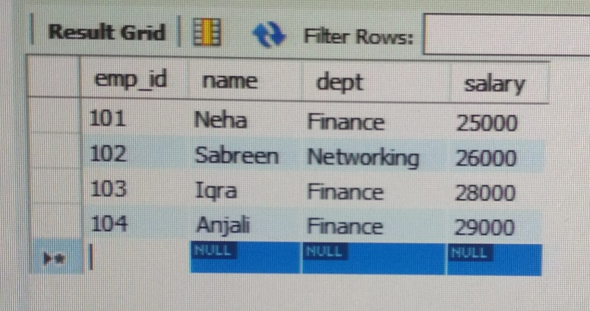

e. delete the data who is having empid = 101

🡪 delete from `student`.`employee` WHERE emp_id = '101';

